4D Ultrasound Cost

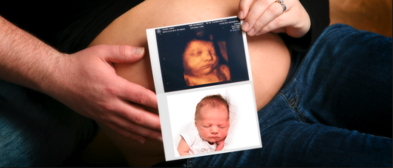
link picture to: http://www.preciousview4d.com/

4D ultrasounds are becoming more and more popular. In the past, most expecting mothers opted for a 3D or even 2D ultrasound; however, times are changing.

What is a 4D ultrasound? 4D and 3D ultrasounds have a number of similarities; they both provide an inside look at your unborn baby. On the other hand, there are many differences between the two. The biggest difference is that 4D ultrasounds project the element of time. 4D ultrasounds allow expecting mothers to watch their baby’s movements in real time. This type of ultrasound produces a video, while 3D ultrasounds focus on still photos.

The best time to have a 4D ultrasound done is between 26 to 30 weeks. Many people believe that the 28th week provides the highest quality photos.

Many ultrasound facilities are offering 3D/4D packages. This means that soon-to-be parents will be able to see their baby in 3D (pictures) as well as 4D (video).

4D ultrasound costs can fluctuate depending on what you would like to get out of the scan. Each facility offers different packages. Furthermore, each package comes with different amenities.

Many facilities have 4D ultrasound costs starting at $50. On the other hand, I have seen packages that cost anywhere from $400 to $500. The price greatly fluctuates due to the fact that one can order a certain amount of photos and can choose the length of the 4D video as well as of the session.

Another factor that affects the price is if the video is in HD LIVE. Certain facilities are currently offering this new technology, which costs more due to its increased quality.

As mentioned, many 4D Ultrasound packages are actually 3D and 4D packages because they come with still photos as well as videos. Standard 4D packages frequently include a 15 to 20 minute 3D/4D ultrasound, gender determination starting at 14 weeks, black and white 2D and 3D pictures, color 3D pictures, and a DVD of the ultrasound session. Other packages include a recording of the baby’s heartbeat and CD’s with an assortment of baby pictures, which is perfect for sharing on the Internet and for printing.

Keyword: 4d Ultrasound cost
Tags: 4D ultrasound, pregnancy, ultrasound, 3D, 4D

